

***Our Code Ngā Tikanga Matatika,***

***Our Standards Ngā Paerewa***

**Workshop Resource Book**

**SEPTEMBER 2019**

# Aims for this session

To:

* review your use of the *Code of Professional Responsibility* *Ngā Tikanga Matatika mō te Haepapa Ngaiotanga (Our Code)* and identify next steps
* deepen your understanding of the *Standards for the Teaching Profession Ngā Paerewa mō te Umanga Whakaakoranga (Our Standards)*
* extend knowledge of effective use of observation and conversations.

# Questions for discussion

What does it mean to be a member of a trusted profession?

|  |
| --- |
|  |

How do Our Values, Ngā Uara influence cultural competence practice in your school, kura, centre or service?

**Whakamana**: *empowering all learners to reach their highest potential by providing high-quality teaching and leadership.*

**Manaakitanga**: *creating a welcoming, caring and creative learning environment that treats everyone with respect and dignity.*

**Pono**: *showing integrity by acting in ways that are fair, honest, ethical and just.*

**Whanaungatanga***: engaging in positive and collaborative relationships with our learners, their families and whānau, our colleagues and the wider community*



# Sharing ideas for Our Code, *Ngā Tikanga Matatika.*

# Touchpoint:

## Have you:

* read and discussed the Examples of Practice?
* reviewed any processes at your place e.g. how new teachers are mentored?
* reviewed your use of social media at your place?
* talked about the Code with your colleagues in team or staff meetings?

## What do you think about:

* how *Our Code, Ngā Tikanga Matatika* supports teaching at your place?
* how *Our Code, Ngā Tikanga Matatika* helps you to think about engaging with children, families and whānau and with each other?
* how *Our Code, Ngā Tikanga Matatika* supports you to interpret any of *Our Standards, Ngā Paerewa?*

## What next?



# *Tapasā*: Cultural Competencies Framework for Teachers of Pacific Learners

*Tapasā* is a new resource to support you to think about quality teaching practices in relation to Pacific learners. It comprises Ngā Turu (competencies) and a framework to help you to ‘become more culturally aware, confident and competent when engaging with Pacific learners and their parents, families and communities’ (p 6). The document will be valuable for assisting you to interpret the *Standards for the Teaching Profession* in your setting. It is not anticipated that these turu will be individually matched to each *Standard*, instead they are likely to be woven through all standards*.*

## Turu 1 Identities, language and cultures

Demonstrate awareness of the diverse and ethnic-specific identities, languages and cultures of Pacific learners.

## Turu 2: Collaborative and respectful relationships and professional behaviours

Establishes and maintains collaborative and respectful relationships and professional behaviours that enhance learning and wellbeing for Pacific learners.

## Turu 3: Effective pedagogies for Pacific learners:

Implements pedagogical approaches that are effective for Pacific learners.

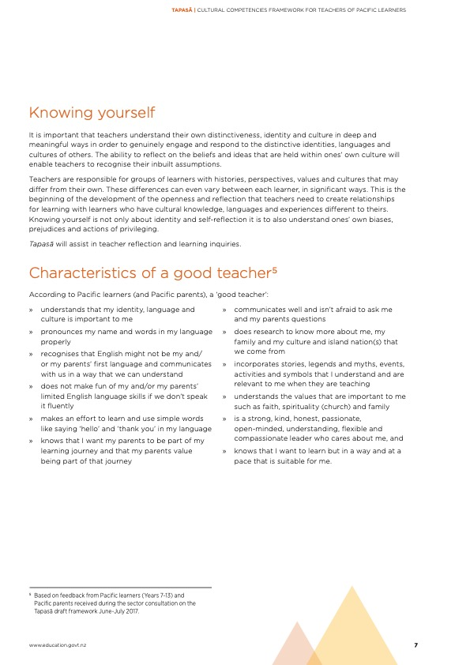

|  |  |  |  |
| --- | --- | --- | --- |
| Self-Analysis  * Remove yourself from your traditional role * Consider the Tapasā indicators for Turu 1 * Where would you place yourself currently in relation to these competencies (Circle one)? | | | |
| Student teacher | Beginning teacher | Experienced teacher | Leader |
| What parts of Turu 1 am I confident I understand and/or practice? How do I know that? |  | | |
| What do I need to do next? |  | | |
| How could using Tapasā help me do this? |  | | |
| The work does the work for you… | How does this thinking you are doing demonstrate work toward the standards? Which ones?  Consider this sentence: **WHEN I** (describe behaviour/action) **I AM DEVELOPING IN** (identify standard or competency) **BECAUSE** (explain) | | |

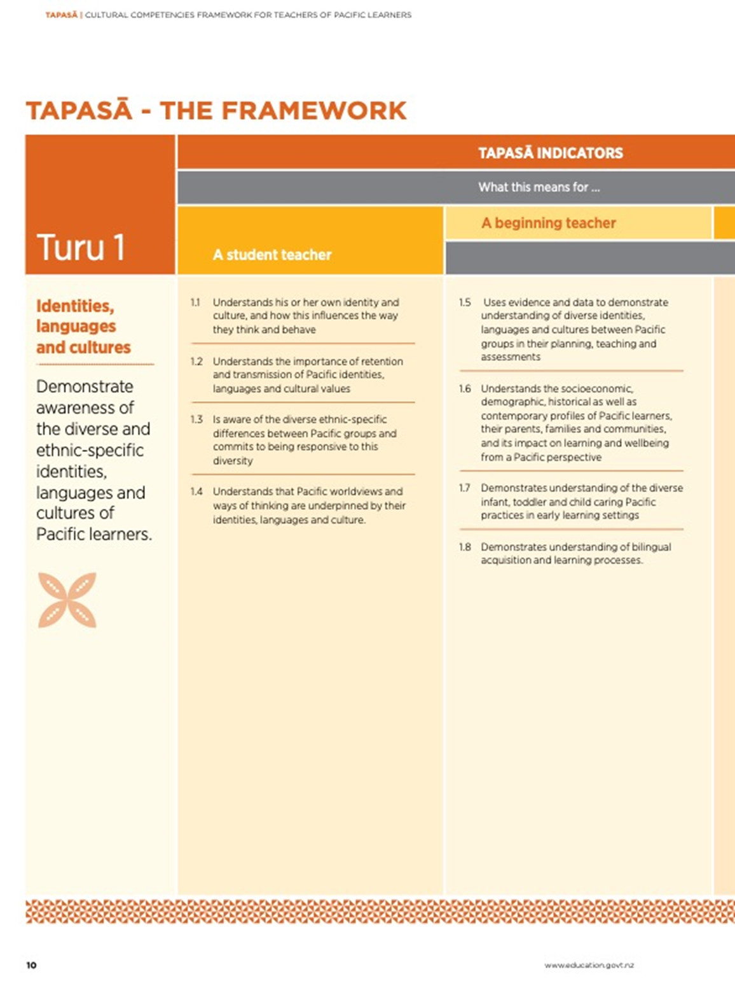



|  |  |
| --- | --- |
| Activity Look at indicator 1.1 in Turu 1 page 10. This is a fundamental building block!  Now go back to page 7 of Tapasā and read the section ‘knowing yourself’  Consider the prompts below: | |
| What are the factors of your own identity and/or culture that influence your thinking about your work (or even this workshop right now)? |  |
| How can understanding that help you to participate or work more effectively/honestly/reflectively? |  |
| How could this thinking connect to the code and standards? |  |

**TANGATA WHENUATANGA**

Arms Māori learners as Māori – provides contexts for learning where the identity, language and culture (cultural locatedness) of Māori learners and their whānau is armed.

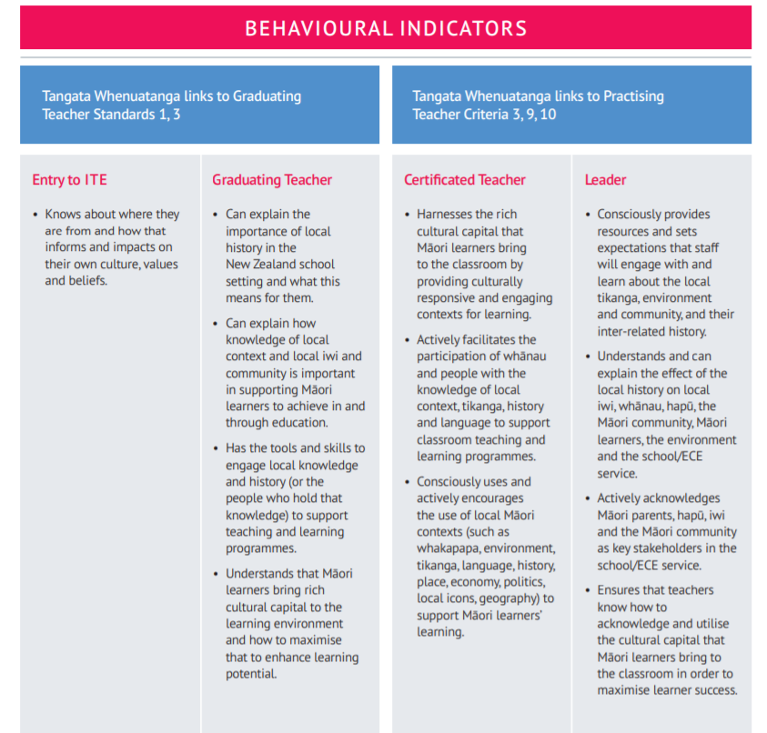

# Standards for the Teaching Profession/Ngā Paerewa mō te Umanga Whakaakoranga

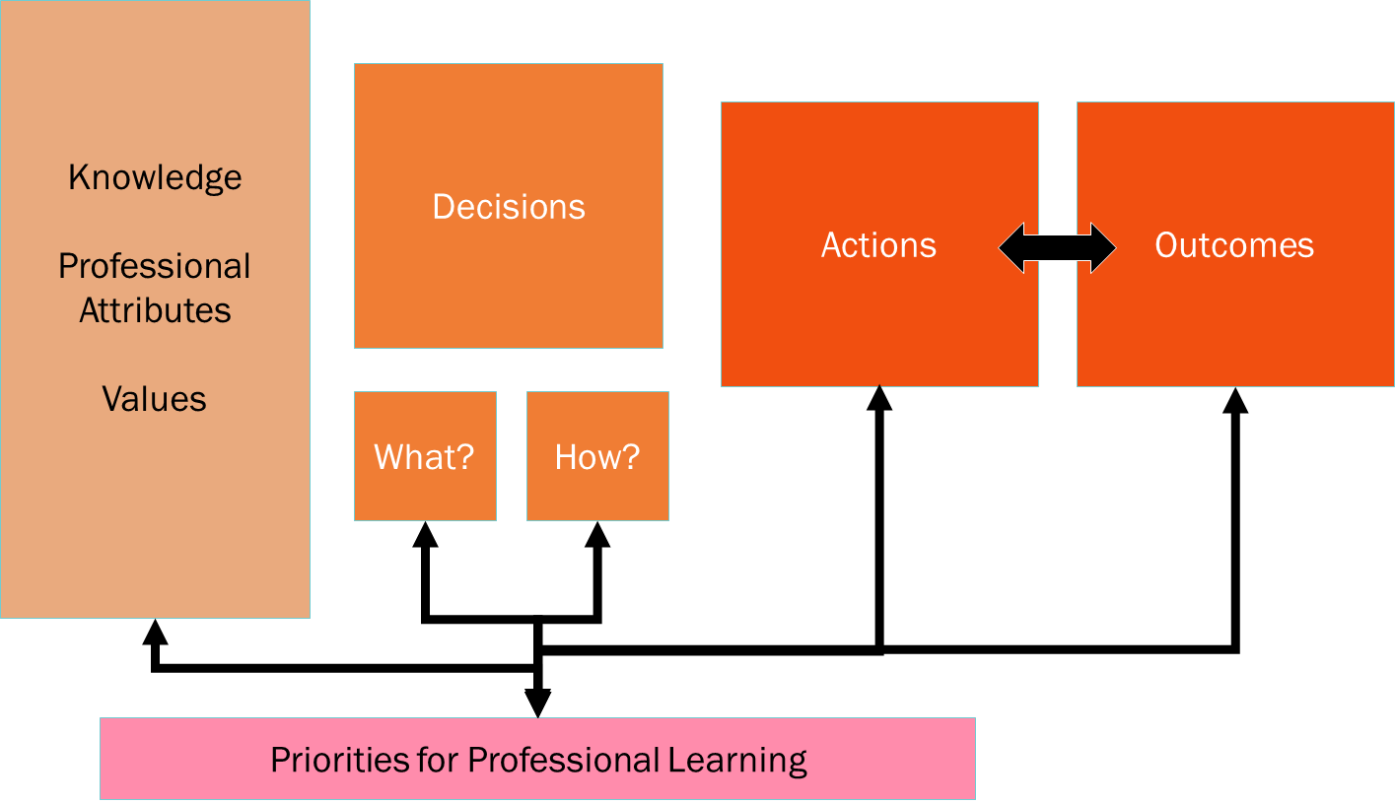

## Professional learning

*Use inquiry and collaborative problem solving and professional learning to improve capability to impact on the learning and achievement of all learners*

* Identify the knowledge, values and attributes
* identify the action and
* identify the outcomes for children, colleagues and others.

## Design for learning

*Design learning based on curriculum and pedagogical knowledge, assessment information and an understanding of each learner’s strengths, interests, needs, identities, languages and cultures*

* Identify the knowledge, values and attributes
* identify the action and
* identify the outcomes for children, colleagues and others.

**Quality Practice Statements**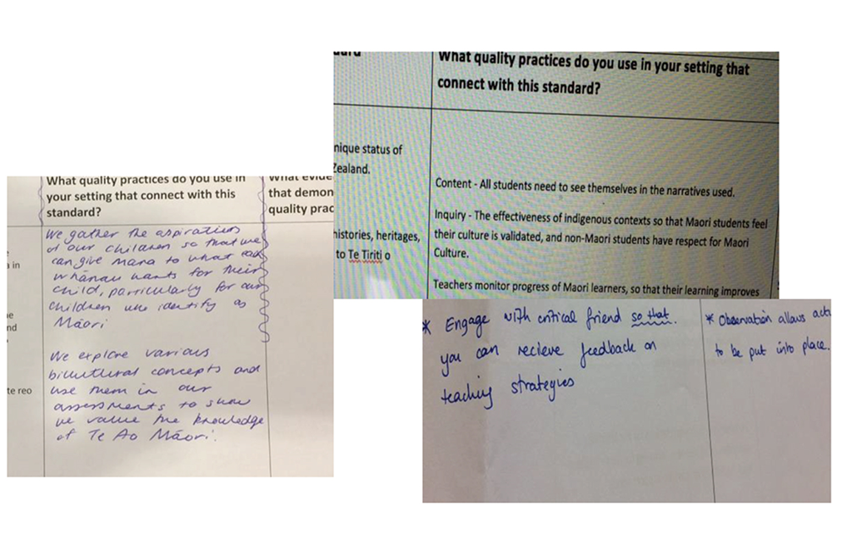

## Analyse the quality practice statements above

Do they reflect the structure of the Standards (knowledge, values and attributes, action and outcomes)?

1. Try rewriting one to reflect the structure of the Standard; what the teacher will do, what knowledge they use or values/attributes they will need, and what the outcomes will be.
2. Try writing one of your own for each of the two Standards on page 7 (Professional Learning and Design for Learning).
3. What would be the naturally occurring evidence?

**Guidelines for completing the Quality Practice Template using the *Standards for the Teaching Profession* in your teaching**

The *Standards for the Teaching Profession* are the same for all English medium settings in Aotearoa New Zealand. Completing the Quality Practice Template together means you together with colleagues will understand the *Standards* as quality practices in your context.

It makes it easier to see the naturally occurring evidence available for professional learning to help you understand the relationship between the standards, teacher practice and learner outcomes. It provides an assurance of what demonstrating the Standards looks like in practice and a clear reference point to see what works well in your setting.

## Completing the template -download as paper or electronic file

*Leading your colleagues to make a start*

* You will need to dedicate half an hour of staff meeting time to work in groups – each group can do one or two Standards.
* Record what the standard looks like in practice (what you already do-that is viewed as quality practice and also what you do/plan to do at the aspirational level). Refer to the standard and work in column three. Refer back to the elaborations as you go for further explanation. You do not need to be matching a quality practice to each elaboration.
* Talk with your colleagues about the naturally occurring evidence you use/analyse as part of these practices. Record it in column four.This evidence already exists and does not need to be ‘gathered’ ‘hyper-linked’ or ‘identified in any additional manner.

## Refining the template

* Display the draft template pages in a shared area e.g. staff room/meeting space so you can all add to or amend it over the next weeks. Leaving post-its nearby encourages participation.
* Revisit the sheets to include the professional learning and development responses you are currently working on e.g. Kāhui Ako achievement challenges, *Te Whariki*. Also use national documents e.g. *The New Zealand Curriculum*; *Ka Hikitia; Success for All*; *Pasifika Education Plan*; *Tātaiako; Te Marautanga o Aotearoa*). You could also use research publications relevant to your context, goals and strategic plan add to/amend/remove anything recorded as a quality practice.
* Talk about whether any of these are ‘must dos’ or ‘might dos’ because they relate to particular roles etc.

## Revisiting over time

* As teachers undertake professional learning or engage in any internal evaluation, discuss and analyse their new understandings/knowledge about quality practice. Add these to your template document.
* Use this reference document for talking about the practices that make a positive difference for learners in your setting.

# Using the Quality Practice Template with the *Standards for the Teaching Profession* - this is an important activity to do with all registered teachers in your setting

|  |  |  |  |
| --- | --- | --- | --- |
| **Standard** | **Elaborations of the standard** | **What quality practices do you use in your setting that connect with this standard?** | **What evidence do you use that demonstrates these quality practices?** |
| Design for learning Design learning based on curriculum and pedagogical knowledge, assessment information and an understanding of each learner’s strengths, interests, needs, identities, languages and cultures | Select teaching approaches, resources, and learning and assessment activities based on a thorough knowledge of curriculum content, pedagogy, progressions in learning and the learners.  Gather, analyse and use appropriate assessment information, identifying progress and needs of learners to design clear next steps in learning and to identify additional supports or adaptations that may be required.  Design and plan culturally responsive, evidence-based approaches which reflect the local community and *Te Tiriti o Waitangi* partnership in New Zealand.  Harness the rich capital that learners bring by providing culturally responsive and engaging contexts for learners.  Informed by national policies and priorities. | *What am I doing as a teacher?* | *What evidence am I using?*  *What will I intend children, students, parents, whānau to be saying or doing?* |

|  |  |  |  |
| --- | --- | --- | --- |
| **Standard** | **Elaborations of the standard** | **What quality practices do you use in your setting that connect with this standard?** | **What evidence do you use that demonstrates these quality practices?** |
| Te Tiriti o Waitangi partnership Demonstrate commitment to tangata whenuatanga and Te Tiriti o Waitangi partnership in Aotearoa New Zealand. | Understand and recognise of the unique status of tangata whenua in Aotearoa New Zealand.  Understand and acknowledge the histories, heritages, languages and cultures of partners to Te Tiriti o Waitangi.  Practise and develop the use of te reo and tikanga Māori. | *What am I doing as a teacher?* | *What evidence am I using?*  *What will I intend children, students, parents, whānau to be saying or doing?* |

**2018 teachers’ ideas about effective appraisal**

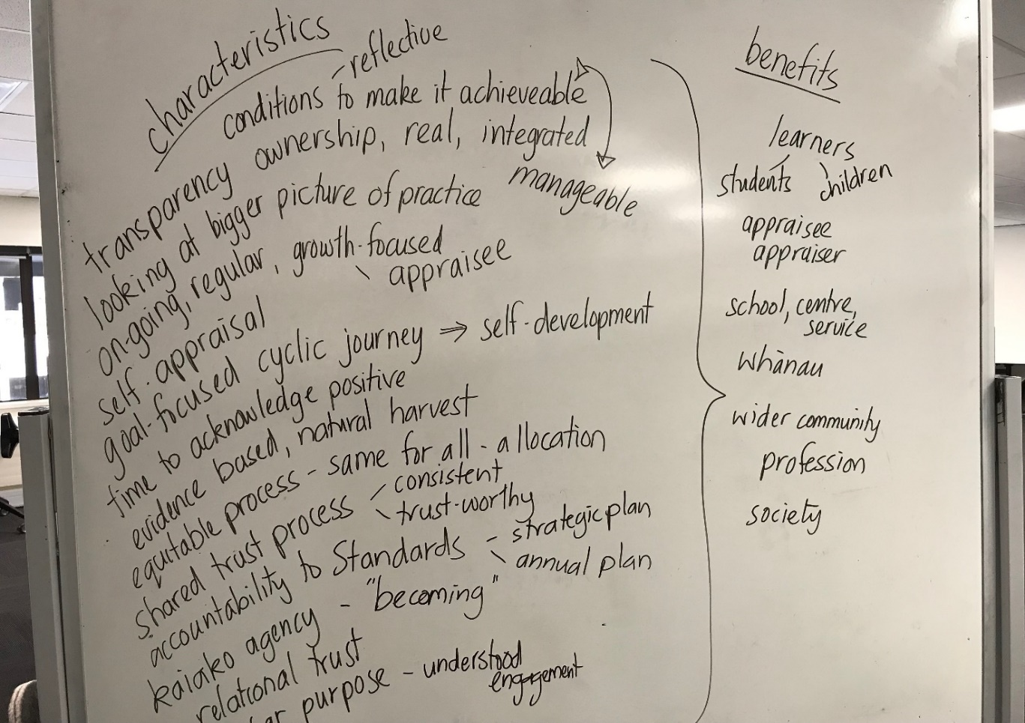

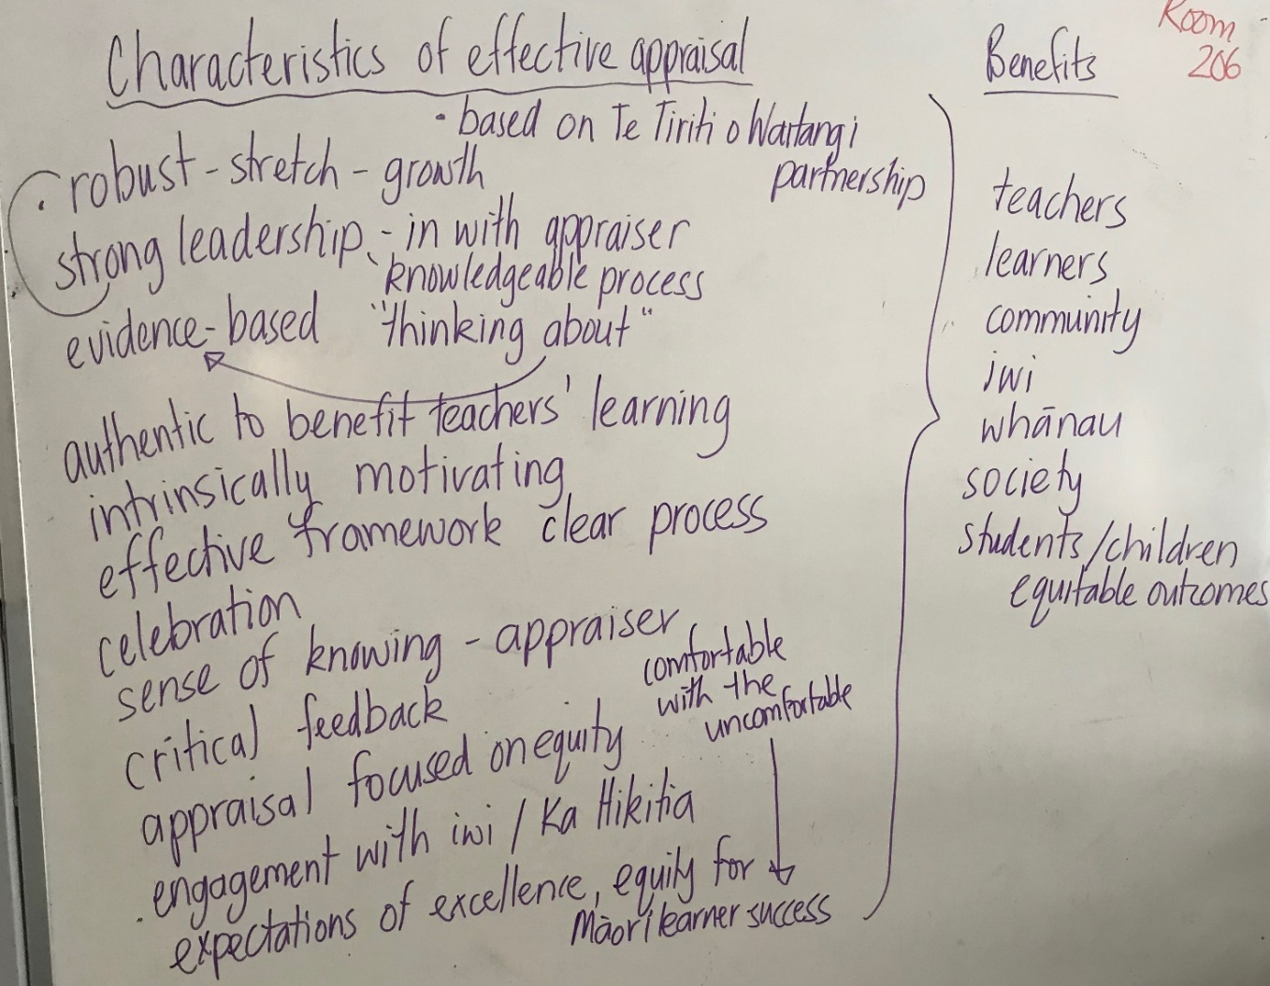

# 



**Formal Observation of Practice** 

Putahi kura pukou o murihiku

**AKO - Teaching and Learning from each other using observation**

|  |  |  |  |
| --- | --- | --- | --- |
| **Teacher:** | | | **Coach:** |
| **Pre observation** | **Goal focus or inquiry question:** | | |
| **Prior discussion** to negotiate focus of Ako Coaching | **Notes** (including date): | |
| **During observation** | **Observation:** Information to help understand what is happening for learners as a direct result of teaching practices  *Observations can be one 15-20 minute observation or planned snapshots of teaching across one or two weeks.* | **Notes** (including dates and times): | |

|  |  |  |
| --- | --- | --- |
| **Post observation** | **Standards for the Teaching Profession:** how do they inform the teaching and the reflective thinking | 1. Demonstrate commitment to tangata whenuatanga and Te Tiriti o Waitangi partnership in Aotearoa New Zealand. 2. Use inquiry, collaborative problem-solving and professional learning to improve professional capability to impact on the learning and achievement of all learners. 3. Establish and maintain professional relationships and behaviours focused on the learning and well-being of each learner. 4. Develop a culture which is focused on learning, and is characterised by respect, inclusion, empathy, collaboration and safety. 5. Design learning based on curriculum and pedagogical knowledge, assessment information and an understanding of each learner’s strengths, interests, needs, identities, languages and cultures. 6. Teach and respond to learners in a knowledgeable and adaptive way to progress their learning at an appropriate depth and pace.   **Notes** |
| **Questions for reflection** on Goal/ inquiry/teaching practice - Coach | **Notes** |
| Teacher reflection: eg: do more, do less, co-construct next steps -with coach. | **Notes** |

# Sharing Ideas

# Appraisal conversations

## **The conversations that take place within the appraisal process ought to be focused on collaboratively evaluating the effectiveness of teaching practice, sharing teacher learning, progress and the consequent changes in outcomes for children and students and on identifying possible next steps and ensuring teaching meets the Standards for the Teaching Profession**

## **Keeping these intentions in mind, add to the list of appraiser questions and to the appraisee statements below.**

# Preparing for conversation starters you use or may use in the future (appraiser)

1. How your teaching is going, how your students or children are going. How you know.
2. What has progressed since last time we met.
3. How you have used what you have learned to inform changes in practice.
4. Celebration / acknowledgement
5. Any aspects of the QPT or *Our Standards, Ngā Paerewa* you have been focusing on.
6. How do you think we are going as a school, centre, service in relation to the Quality Practice Template?
7. Anything you are working on?

# Preparing for conversation starters you use or may use in the future (appraisee)

1. My inquiry. How it is going. What I have learned.
2. What I have noticed about my changed practice and the impact on my learners.
3. The various sources and perspectives I have used and analysed in my evidence and what that tells me about how my teaching has impacted on my learners, and my practice in light of the QPT or *Our Standards, Ngā Paerewa.*

4.

5.

# Annual Appraisal Summary Report (to be changed as appropriate to your setting)

**Date**

|  |  |
| --- | --- |
| **Appraisee:** |  |
| **Appraiser:** |  |

# Discussion between appraiser and appraisee made reference to…

*the basis for the discussion will be decided by the appraiser and appraisee and may include the following information*

|  |  |  |  |  |
| --- | --- | --- | --- | --- |
|  | **Previous appraisal conversation notes** | **Professional learning**  **focus** | **Observation and feedback notes** | **Other** |
| **Date**  **Appraiser** |  |  |  |  |

Summary Statement*– this section indicates how the teacher’s participation in the appraisal system has supported their understanding of the relationship between their teaching practice, outcomes for learners and the Standards.*

|  |
| --- |
|  |

# Statement of meeting /not yet meeting the Standards

|  |
| --- |
| Please indicate which applies:  With reference to the evidence and discussion between appraisee and appraiser all *Standards for the Teaching Profession*and the *Professional Standards* **have been met** in this appraisal cycle.  **OR**  With reference to the evidence and discussion between appraisee and appraiser the following *Standards for the Teaching Profession* and the *Professional Standards* **have not YET been met** (timeline and actions) in this appraisal cycle.  **For any teacher whose practice does not yet meet the *Standards,* indicate the support to be given and the timeframe.** |

Next steps for teacher development*– this section will indicate the agreed focus for the teacher’s on-going learning*

|  |
| --- |
|  |

Signatures

|  |  |
| --- | --- |
| ……………………………………………………………………………………………………  Appraiser | ……………………………………..  Date |
| ……………………………………………………………………………………………………  Appraisee | ……………………………………..  Date |
| ……………………………………………………………………………………………………  Principal/Professional Leader | ……………………………………..  Date |

**Appendix 1:**

Message to the profession about appraisal

As part of the collective bargaining between the Government, PPTA Te Wehengarua and NZEI Te Riu Roa, an ‘Accord’ was developed with the intent of building an environment where the teaching profession is highly regarded, sustainable, and fit for now and the future of learning. The Accord was ratified by PPTA Te Wehengarua and NZEI Te Riu Roa members. [Please use this link to read more.](http://www.education.govt.nz/news/collective-bargaining-fact-sheet-13-june-2019/)

One element of the Accord commits to removing teacher performance appraisal as an accountability instrument, in recognition that in some settings the process has become burdensome. It is the intention of the Teaching Council, NZ School Trustees’ Association and the parties to the Accord to totally rethink appraisal and the policies it connects to like renewal of a practising certificate. We intend to create policies that demonstrate professional trust, freeing teachers up to focus on their development journey.

This commitment offers an exciting step forward. We have begun the planning and scoping for how we will engage with the broader profession in the development process ensuring any changes we make will be for the whole profession, including the ECE sector. Some of the changes will be developed quite quickly whilst others, like a potential removal of the requirement in legislation to audit appraisal, will take much longer.

Right now, nothing has changed. However, it is timely to have another look at your organisation’s appraisal process to see if it has become overly compliance focused.

The Teaching Council would like to clarify what it expects for the issue or renewal of a practising certificate.

The issue or renewal of a practising certificate will be based on an endorsement made by the professional leader, based on the teacher’s participation in a system that includes:

* an annual summary report that states whether or not the appraisee meets the standards or ngā paerewa.
  + The annual summary report is the only teacher documentation that is required for the purposes of the audit ERO undertakes on behalf of the Teaching Council
* that appraisees have been observed once annually and involved in two conversations ideally with an appraiser who is familiar with the day to day work of the teacher.
  + The Council has listened to the profession and accepts that one observation may suffice for fully certificated teachers.

We do not ask (nor do we require) to see copies of the annual summary report, or any evidence. We rely on the professional judgement of the appraiser and the leader making the endorsement.

While schools and centres are free to design their appraisal processes there is no requirement in law or by any agency that an appraisal system must include:

* 1. an inquiry to be undertaken by teachers
  2. reports to be kept of all the professional development teachers do
  3. a portfolio of evidence compiled by teachers